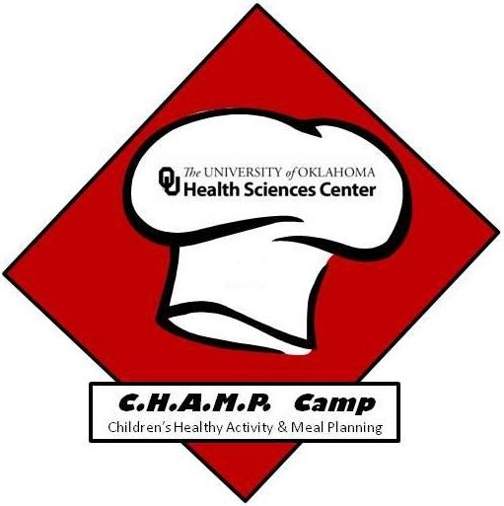
Name:_______________________________

Champ Camp Pre-Test

- What do vitamins and minerals do for our body?
  - Used to make our muscles contract
  - Help our body make energy
  - Support bone growth
  - All of the above

- Where can we get a source of vitamin C?
  - Meat
  - Oranges
  - Plain yogurt

- What types of trash can you recycle?
  - Plastic bottles
  - Pizza Boxes
  - Cans
  - A and C
  - All the above

- What are the three Rs of sustainability?
  - Reduce, Reuse, Recycle
  - Replace, Reuse, Recan
  - Restart, Replan, Recycle
  - Replant, Reduce

- How many servings of fruits should you try to eat every single day?
  - 1 serving
  - 4 - 5 servings
  - 1.5 - 2 servings

- How many servings of dairy should you try to have every single day?
  - 1 serving
  - 3 servings
  - 4 servings

- Where did ice cream originally come from?
  - France
  - Italy
  - Persia
  - Spain

- What is the recommended serving size of ice cream?
  - 1 cup
  - ½ cup
  - ¼ cup
  - 1 pint

- How does water improve your health?
  - Keeps your body a normal temperature
  - Cushions your joints
  - Cleanses our body by getting rid of waste
  - Protects sensitive body parts
  - All of the above

- Your body needs more water when you are physically active.
  - True
  - False

- How long do you need to wash your hands for?
  - 5 seconds
  - 10 seconds
  - 20 seconds
  - 30 seconds

- Should you have different cutting boards for meat and vegetables?
  - Yes
  - No

- Which of the following is a chemical change?
  - Chopping a tree in half
  - Ripping a piece of paper
  - Freezing water
  - Burning a piece of paper

- Which of the following is a base?
  - Baking soda
  - Vinegar
  - Lemon juice
  - Coca-Cola

- True or False: Foods high in sodium can increase bad cholesterol.
  - True
  - False

- True or False: The ingredients on a food label are listed from smallest to largest.
  - True
  - False

- What food group does fiber belong to?
  - Protein
  - Carbohydrates
  - Fat
  - Vitamins

- Which choice is a health benefit of eating fiber?
  - Makes you run faster
  - Makes you taller
  - Helps you poop

